

LAB REPORT

ICT (“Information & communication Technology Fundamental”)

For the degree of Bacheller of science

In Computer Science

Session 2k24

**Name:** Bareera Fatima

**Roll No:** 126

**Section:** SE-A

**Submitted to:** Ms. Fabia Hassan

**Submitted by**: Bareera Fatima

December 2024

**TYPING PRACTICE**

here some typing practice exercises and a tutorial on internal components of computers with diagrams:

* Typing Practice Exercises
* Finger Placement: Place your fingers on the home row keys (ASDF for the left hand and JKL; for the right hand). Practice typing the following keys without looking at the keyboard:
  + Left hand: ASDF
  + Right hand: JKL;
* Typing Drills: Practice typing the following drills to improve your typing speed and accuracy:
  + Typing a single key repeatedly
  + Typing a sequence of keys
  + Typing a short sentence or phrase (e.g., "The quick brown fox jumps over the lazy dog.")
* Typing Games: Play online typing games, such as KeyBlaze, Typing Club, Nitro type or to make typing practice more engaging and fun.
* 
* **COMPONENTS OF COMPUTER**
* Here are the internal components of a computer:
* CPU (Central Processing Unit)
* Control Unit: Retrieves and decodes instructions, manages data transfer between components.
* Arithmetic Logic Unit (ALU): Performs mathematical and logical operations.
* Registers: Small amounts of memory built into the CPU to store data temporarily.
* Motherboard
* Chipset: Manages data transfer between components.
* RAM Slots: Holds memory modules.
* Expansion Slots: Allows installation of expansion cards (e.g., graphics, sound).
* CPU Socket: Holds the CPU in place.
* Power Connectors: Connects power cables from the power supply.
* Memory (RAM)
* DIMM (Dual In-Line Memory Module): A type of RAM module.
* SIMM (Single In-Line Memory Module): An older type of RAM module.
* Storage Devices
* Hard Disk Drive (HDD): A traditional storage device that uses spinning disks and magnetic heads.
* Solid-State Drive (SSD): A faster, more modern storage device that uses flash memory.
* Optical Drive: A device that reads and writes data to optical discs (e.g., CDs, DVDs, Blu-rays).
* Power Supply
* Power Cables: Connects to components (e.g., CPU, motherboard, storage devices).
* Voltage Regulator: Regulates the voltage output to components.
* 3. Cooling System: Helps to dissipate heat generated by the power supply.
* Graphics Card
* GPU (Graphics Processing Unit): Handles graphics processing and rendering.
* Memory: Dedicated memory for graphics processing.
* 3. Cooling System: Helps to dissipate heat generated by the graphics card.
* Sound Card
* Audio Processing Unit: Handles audio processing and rendering.
* Audio Connectors: Connects to speakers, headphones, or other audio devices.
* Networking Components
* Ethernet Card: Connects to a network via Ethernet cable.
* Wi-Fi Adapter: Connects to a network via Wi-Fi.
* Bluetooth Adapter: Connects to devices via Bluetooth.
* Cooling System
* CPU Cooler: Helps to dissipate heat generated by the CPU.
* Case Fans: Helps to circulate air and dissipate heat within the computer case.
* Liquid Cooling System: A more advanced cooling system that uses liquid to dissipate heat.





**WINDOW INSTALLATION**

* here's a step-by-step guide on window installation:

**Pre-Installation Checklist**

* Measure the window opening: Measure the width and height of the window opening to ensure the new window fits properly.
* Check the window frame: Inspect the window frame for any damage or rot. Make any necessary repairs before installing the new window.
* Gather necessary tools and materials: Make sure you have all the necessary tools and materials, including a level, tape measure, safety glasses, and a hammer.

**Step 1: Remove the Old Window**

* Remove the interior trim: Remove the interior trim and molding around the window to access the old window.
* Remove the old window: Carefully remove the old window from the window frame. If the window is stuck, use a pry bar to gently loosen it.
* Remove any remaining debris: Remove any remaining debris or old caulk from the window frame.

**Step 2: Prepare the Window Frame**

* Inspect the window frame: Inspect the window frame for any damage or rot. Make any necessary repairs before proceeding.
* Clean the window frame: Clean the window frame to ensure a smooth installation process.
* Apply new caulk: Apply new caulk to the window frame to ensure a watertight seal.

**Step 3: Install the New Window**

* Place the new window: Carefully place the new window into the window frame, ensuring it is properly seated and aligned.
* Secure the window: Secure the window to the window frame using screws or nails.
* Add any finishing touches: Add any finishing touches, such as interior trim and molding.
* **Step 4: Final Inspection and Testing**
* Inspect the window installation: Inspect the window installation to ensure it is properly seated and secured.
* Test the window: Test the window to ensure it operates smoothly and properly.
* Make any necessary adjustments: Make any necessary adjustments to the window installation to ensure proper operation.

**Safety Precautions**

* Wear safety glasses: Wear safety glasses to protect your eyes from debris and other hazards.
* Use a ladder safely: Use a ladder safely and securely to access high areas.
* Avoid overexertion: Avoid overexertion when lifting and moving heavy objects.

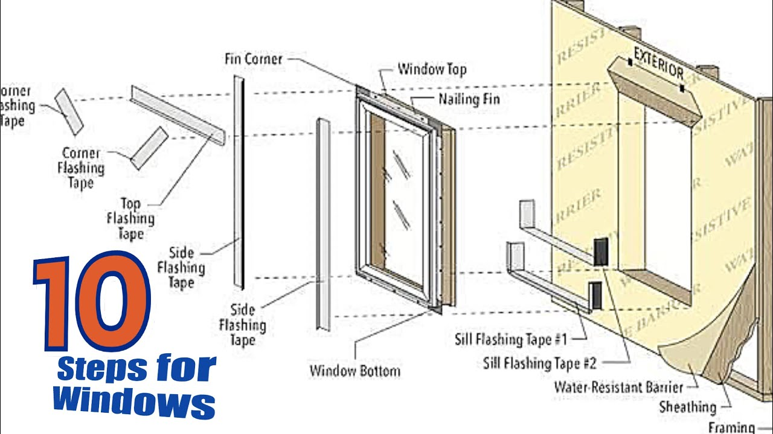

**CPU ASSEMBLING**

Here's a step-by-step guide on CPU assembling:

* Tools and Materials Needed
* CPU (Central Processing Unit)
* Motherboard
* RAM (Random Access Memory)
* GPU (Graphics Processing Unit) (optional)
* CPU cooler
* Thermal paste
* Screwdrivers
* Trox driver (if applicable)
* Safety glasses
* Anti-static wrist strap
* Step 1: Unpack and Prepare the Components
* Unpack the CPU, motherboard, RAM, and GPU (if applicable) from their packaging.
* Ground yourself by touching a grounded metal object or wearing an anti-static wrist strap.
* Step 2: Install the CPU
* Locate the CPU socket on the motherboard
* Remove the CPU socket cover.
* Apply a thin layer of thermal paste to the CPU die (the top surface).
* Carefully insert the CPU into the socket, ensuring it is aligned with the pins.
* Secure the CPU using the socket's locking mechanism.
* Step 3: Install the CPU Cooler
* Locate the CPU cooler mounting holes on the motherboard.
* Apply a thin layer of thermal paste to the CPU cooler's base.
* Carefully attach the CPU cooler to the motherboard, ensuring it is securely fastened.
* Step 4: Install the RAM
* Locate the RAM slots on the motherboard.
* Align the RAM modules with the slots, ensuring the notches on the RAM match the tabs on the slot.
* Secure the RAM modules using the slot's locking mechanism.
* Step 5: Install the GPU (if applicable)
* Locate the PCIe slot on the motherboard.
* Align the GPU with the slot, ensuring the gold contacts on the GPU match the slot's connectors.
* Secure the GPU using the slot's locking mechanism.
* Step 6: Connect the Front Panel and Fans
* Connect the front panel headers to the motherboard.
* Connect the fan headers to the motherboard.
* Step 7: Connect the Power Cables
* Connect the power cables to the motherboard.
* Connect the power cables to the GPU (if applicable).
* Step 8: Boot Up the System
* Plug in the power cord.
* Press the power button.
* The system should now boot up.

Safety Precautions

* Wear safety glasses: Wear safety glasses to protect your eyes from debris and other hazards.
* Use an anti-static wrist strap: Use an anti-static wrist strap to prevent damage to components from static electricity.
* Avoid overexertion: Avoid overexertion when lifting and moving heavy objects.

**MOTHERBOARD AND ITS INTERNAL COMPONENTS**

* Here's a step-by-step guide on CPU assembling:
* Tools and Materials Needed
* CPU (Central Processing Unit)
* Motherboard
* RAM (Random Access Memory)
* GPU (Graphics Processing Unit) (optional)
* CPU cooler
* Thermal paste
* Screwdrivers
* Torx driver (if applicable)
* Safety glasses
* Anti-static wrist strap
* Step 1: Unpack and Prepare the Components
* Unpack the CPU, motherboard, RAM, and GPU (if applicable) from their packaging.
* Ground yourself by touching a grounded metal object or wearing an anti-static wrist strap.
* Step 2: Install the CPU
* Locate the CPU socket on the motherboard.
* Remove the CPU socket cover.
* Apply a thin layer of thermal paste to the CPU die (the top surface).
* Carefully insert the CPU into the socket, ensuring it is aligned with the pins.
* Secure the CPU using the socket's locking mechanism.
* Step 3: Install the CPU Cooler
* Locate the CPU cooler mounting holes on the motherboard.
* Apply a thin layer of thermal paste to the CPU cooler's base.
* Carefully attach the CPU cooler to the motherboard, ensuring it is securely fastened.
* Step 4: Install the RAM
* Locate the RAM slots on the motherboard.
* Align the RAM modules with the slots, ensuring the notches on the RAM match the tabs on the slot.
* Secure the RAM modules using the slot's locking mechanism.
* Step 5: Install the GPU (if applicable)
* Locate the PCIe slot on the motherboard.
* Align the GPU with the slot, ensuring the gold contacts on the GPU match the slot's connectors.
* Secure the GPU using the slot's locking mechanism.
* Step 6: Connect the Front Panel and Fans
* Connect the front panel headers to the motherboard.
* Connect the fan headers to the motherboard.
* Step 7: Connect the Power Cables
* Connect the power cables to the motherboard.
* Connect the power cables to the GPU (if applicable).
* Step 8: Boot Up the System
* Plug in the power cord.
* Press the power button.
* The system should now boot up.
* Safety Precautions
* Wear safety glasses: Wear safety glasses to protect your eyes from debris and other hazards.
* Use an anti-static wrist strap: Use an anti-static wrist strap to prevent damage to components from static electricity.
* Avoid overexertion: Avoid overexertion when lifting and moving heavy objects.

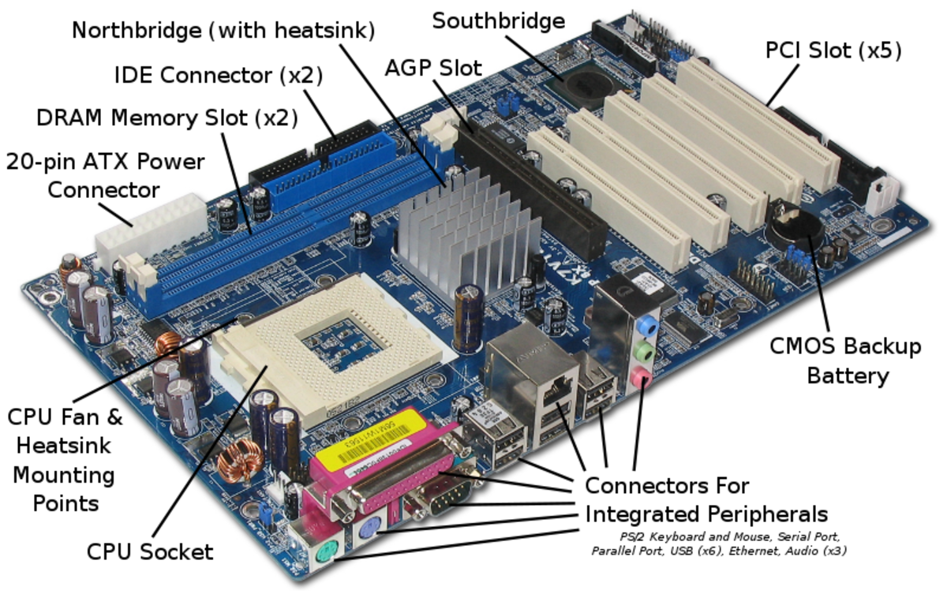

**INTRODUCTION TO MS OFFICE**



* What is Microsoft Office?
* Microsoft Office is a suite of productivity software developed by Microsoft. It includes a range of applications that enable users to create, edit, and manage various types of documents, spreadsheets, presentations, and databases.
* Components of Microsoft Office
* The Microsoft Office suite typically includes the following applications:
* Microsoft Word: A word processing application for creating and editing document

* Microsoft Excel: A spreadsheet application for creating and editing spreadsheets.
* Microsoft PowerPoint: A presentation application for creating and editing presentations.
* Microsoft Outlook: An email client application for managing email, calendars, and contacts.
* Microsoft Access: A database management application for creating and managing databases.
* Microsoft Publisher: A desktop publishing application for creating and editing publications.
* Features and Benefits of Microsoft Office
* Microsoft Office offers a range of features and benefits, including:
* User-friendly interface: Microsoft Office applications have an intuitive interface that makes it easy to create and edit documents.
* Robust formatting options: Microsoft Office applications offer a range of formatting options, including fonts, colors, and graphics.
* Collaboration tools: Microsoft Office applications include collaboration tools, such as real-time co-authoring and commenting.
* Integration with other Microsoft applications: Microsoft Office applications integrate seamlessly with other Microsoft applications, such as OneDrive and SharePoint.
* Security and compliance: Microsoft Office applications include robust security and compliance features, such as data encryption and access controls.

**MS WORD BASIC FEATURES**

Here are the basic features of Microsoft Word:



**Text Editing Features**

Typing and Editing: Type and edit text, including deleting, cutting, copying, and pasting.

Font and Size: Change font, size, color, and style (bold, italic, underline).

Alignment: Align text left, right, center, or justified.

**Document Formatting Features**

* Margins and Orientation: Set margins, orientation (portrait or landscape), and paper size.
* Headers and Footers: Add headers and footers to display information such as page numbers, dates, and titles.
* Page Breaks: Insert page breaks to start a new page.
* **Graphics and Multimedia Features**
* Image Insertion: Insert images from files, online sources, or cameras.
* Image Editing: Edit images using basic tools such as resizing, cropping, and adjusting brightness and contrast.
* Tables and Charts: Create tables and charts to organize and visualize data.
* Review and Revision Features
* Spell and Grammar Check: Check spelling and grammar errors.
* Track Changes: Track changes made to a document.
* Comments: Add comments to a document.
* Printing and Sharing Features
* Print: Print documents on paper or to a PDF file.
* Save: Save documents in various file formats, including Word (.docx), PDF, and text files.
* Share: Share documents via email, online storage services, or social media platforms.
* Other Basic Features
* Undo and Redo: Undo and redo actions.
* Find and Replace: Find and replace text.
* 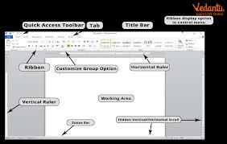

**MS WORD ADVANCED FEATURES**

* Here are some advanced features in Microsoft Word, including mail merge, table of contents, section breaks and references, and header and footer:

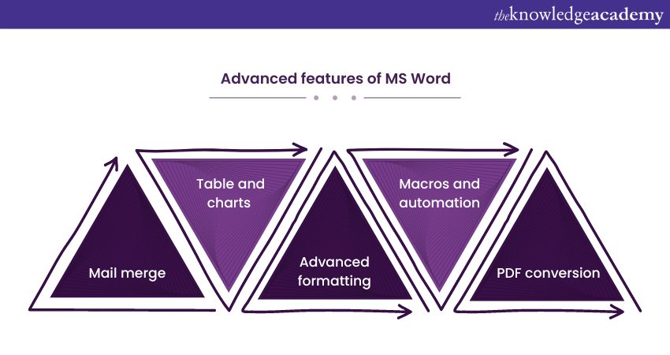

**Mail Merge**

* Create a data source: Create a data source, such as an Excel spreadsheet or a Word table, that contains the data you want to merge into your document.
* Connect to the data source: Connect to the data source by going to the "Mailings" tab and clicking on "Select Recipients".
* 3. Insert merge fields: Insert merge fields into your document by going to the "Mailings" tab and clicking on "Insert Merge Field".
* 4. Preview and merge: Preview the merged document by going to the "Mailings" tab and clicking on "Preview Results". Then, merge the data into the document by clicking on "Finish & Merge".

**Table of Contents**

* 1. Create headings: Create headings in your document by applying heading styles (e.g. Heading 1, Heading 2, etc.).
* 2. Insert a table of contents: Insert a table of contents by going to the "References" tab and clicking on "Table of Contents".
* 3. Customize the table of contents: Customize the table of contents by right-clicking on it and selecting "Edit Field".
* 4. Update the table of contents: Update the table of contents by right-clicking on it and selecting "Update Field".

**Section Breaks and References**

* 1. Insert a section break: Insert a section break by going to the "Layout" tab and clicking on "Breaks".
* 2. Create a reference: Create a reference by going to the "References" tab and clicking on "Insert Citation".
* 3. Insert a cross-reference: Insert a cross-reference by going to the "References" tab and clicking on "Cross-reference".
* 4. Update the references: Update the references by right-clicking on them and selecting "Update Field".

**Header and Footer**

* 1. Insert a header or footer: Insert a header or footer by going to the "Insert" tab and clicking on "Header" or "Footer".
* 2. Customize the header or footer: Customize the header or footer by right-clicking on it and selecting "Edit Header" or "Edit Footer".
* 3. Insert page numbers: Insert page numbers by going to the "Insert" tab and clicking on "Page Number".
* 4. Insert a date or time: Insert a date or time by going to the "Insert" tab and clicking on "Date & Time".

**Efficient Use of Header and Footer**

* 1. Use the "Link to Previous" feature: Use the "Link to Previous" feature to link headers and footers across multiple sections.
* 2. Use the "Different First Page" feature: Use the "Different First Page" feature to create a different header or footer for the first page of a document.
* 3. Use the "Different Odd and Even Pages" feature: Use the "Different Odd and Even Pages" feature to create different headers or footers for odd and even pages.
* 4. Use the "Section Break" feature: Use the "Section Break" feature to create separate headers and footers for different sections of a document.

**Here's an overview of using Mendeley, Grammarly, and PDF Element, as well as automation with macros, referencing tools, and citations:**

**Mendeley**

* Mendeley is a reference management tool that helps you organize and format your citations and bibliographies.
* Create a Mendeley account: Sign up for a Mendeley account and download the desktop app.
* Add references: Add references to your Mendeley library by importing them from databases, websites, or other reference management tools.
* Organize references: Organize your references into folders and tags to make them easy to find.
* Cite references: Use Mendeley's citation plugin to cite your references in your Word document.
* Format bibliographies: Use Mendeley to format your bibliographies in various citation styles.

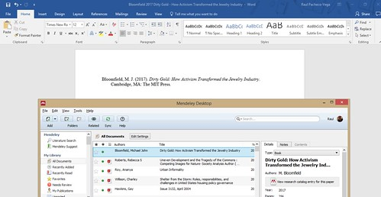

**Grammarly**

* Grammarly is a writing tool that helps you improve the grammar, spelling, and style of your writing.
* Create a Grammarly account: Sign up for a Grammarly account and download the desktop app or browser extension.
* Write and edit: Write and edit your document as you normally would.
* Run Grammarly: Run Grammarly on your document to check for grammar, spelling, and style errors.
* Review and revise: Review Grammarly's suggestions and revise your document accordingly.

**PDF Element**

* PDF Element is a PDF editing tool that helps you edit, convert, and annotate PDF files.
* Create a PDF Element account: Sign up for a PDF Element account and download the desktop app.
* Open a PDF file: Open a PDF file in PDF Element.
* Edit the PDF: Edit the PDF by adding text, images, and annotations.
* Convert the PDF: Convert the PDF to other file formats, such as Word or Excel.
* Annotate the PDF: Annotate the PDF by adding comments, highlights, and underlines.

**Automation with Macros**

* Macros are automated scripts that can perform repetitive tasks in Word.
* Create a macro: Create a macro by going to the "Developer" tab and clicking on "Record Macro".
* Record the macro: Record the macro by performing the repetitive task.
* Save the macro: Save the macro by giving it a name and clicking on "Save".
* Run the macro: Run the macro by going to the "Developer" tab and clicking on "Macros".
* Assign a shortcut: Assign a shortcut to the macro by right-clicking on the macro and selecting "Assign Shortcut".
* Referencing Tools and Citations
* Referencing tools and citations help you format your references and citations correctly.
* Use a referencing tool: Use a referencing tool, such as Mendeley or Zotero, to format your references and citations.
* Choose a citation style: Choose a citation style, such as APA or MLA, and use it consistently throughout your document.
* Insert citations: Insert citations into your document by using the citation plugin or by typing them in manually.
* Format the bibliography: Format the bibliography by using the referencing tool or by typing it in manually.

**Footnotes and Endnotes**

* Footnotes and endnotes are used to provide additional information or citations in a document.
* Insert a footnote or endnote: Insert a footnote or endnote by going to the "References" tab and clicking on "Insert Footnote" or "Insert Endnote".
* Format the footnote or endnote: Format the footnote or endnote by using the "Footnote and Endnote" dialog box.
* Convert footnotes to endnotes: Convert footnotes to endnotes by going to the "References" tab and clicking on "Convert Footnotes to Endnotes".

**Here's an overview of mail management, collaborative tools, and document protection in Microsoft Word:**

**Mail Management**

* Create and send emails: Create and send emails directly from Microsoft Word using the "Email" button in the "Share" group.
* Attach files: Attach files to emails, including Word documents, PDFs, and images.
* Use mail merge: Use mail merge to create personalized emails for multiple recipients.

**Collaborative Tools**

* Track changes: Track changes made to a document by multiple authors using the "Track Changes" feature.
* Add comments: Add comments to a document to provide feedback or ask questions.
* Collaborate in real-time: Collaborate with others in real-time using Microsoft Word's co-authoring feature.

**Document Protection**

* Protect with password: Protect a document with a password to prevent unauthorized access.
* Control editing permissions: Control editing permissions by restricting who can edit a document and what changes they can make.
* Use digital signatures: Use digital signatures to authenticate the identity of the document's author and ensure the document's integrity.

**Master Reviewing and Comparing Documents**

* Use the "Review" tab: Use the "Review" tab to access tools for reviewing and comparing documents.
* Compare documents: Compare two versions of a document to see what changes have been made.
* Use the "Combine" feature: Use the "Combine" feature to combine multiple versions of a document into a single document.

**Protect Documents with Password and Control Editing Permission**

* Go to the "Review" tab: Go to the "Review" tab and click on "Protect Document".
* Select "Encrypt with Password": Select "Encrypt with Password" to protect the document with a password.
* Set editing permissions: Set editing permissions by selecting "Restrict Editing" and choosing who can edit the document and what changes they can make.

**MS EXCEL**



**Introduction to MS Excel**

* Microsoft Excel is a spreadsheet software used for data analysis, visualization, and management. It's widely used in various industries, including business, finance, and education.

**Basic Skills in MS Excel**

* Here are some basic skills to get you started with MS Excel:
* Creating and Saving a Workbook
  + Open MS Excel and click on "File" > "New" to create a new workbook.
  + Save your workbook by clicking on "File" > "Save As" and choosing a location.
* Understanding the Excel Interface
  + Familiarize yourself with the Excel interface, including the ribbon, tabs, and formula bar.
* Entering and Editing Data
  + Enter data into cells by typing or pasting.
  + Edit data by selecting the cell and making changes.
* Basic Arithmetic Operations
  + Perform basic arithmetic operations like sum, average, and count using formulas.
* Formatting Cells
  + Format cells by changing font, alignment, and number formatting.
* Basic Charting
  + Create basic charts like column, line, and pie charts to visualize data.
* Basic Formula Writing
  + Write basic formulas using arithmetic operators and cell references.
* Copying and Pasting
  + Copy and paste data within and across worksheets.
* Basic Data Management
  + Manage data by sorting, filtering, and grouping.
* Basic Printing
  + Print worksheets and workbooks by selecting print options.

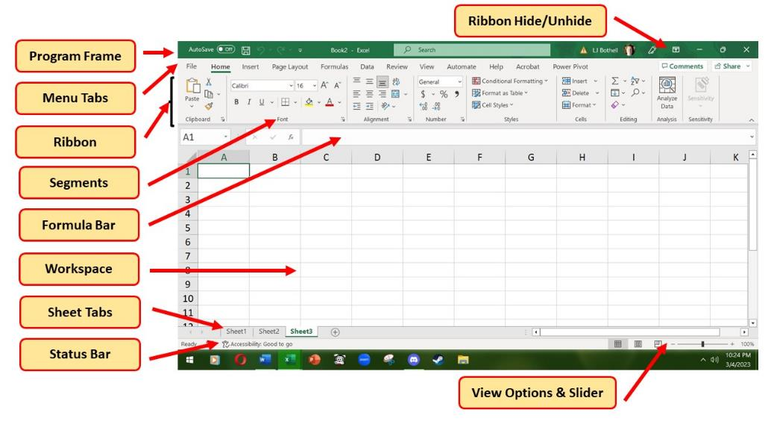

**MS EXCEL FORMULAS**

**Arithmetic Formulas**

* SUM: =SUM (range) - Adds up a range of cells.
* AVERAGE: =AVERAGE (range) - Calculates the average of a range of cells.
* COUNT: =COUNT (range) - Counts the number of cells in a range that contain numbers.
* PRODUCT: =PRODUCT (range) - Multiplies a range of cells.

**Text Formulas**

* CONCATENATE: =CONCATENATE (text1, [text2], ...) - Joins two or more text strings together.
* LOWER: =LOWER (text) - Converts text to lowercase.
* UPPER: =UPPER (text) - Converts text to uppercase.
* PROPER: =PROPER (text) - Converts text to proper case.

**Date and Time Formulas**

* TODAY: =TODAY () - Returns the current date.
* NOW: =NOW () - Returns the current date and time.

**lookup and Reference Formulas**

* VLOOKUP: =VLOOKUP (lookup_value, table array, col_index_num, [range lookup]) - Looks up a value in a table and returns a corresponding value from another column.
* INDEX/MATCH: =INDEX (range, MATCH (lookup_value, lookup array, [match type]) - Looks up a value in a table and returns a corresponding value from another column.
* HLOOKUP: =HLOOKUP (lookup_value, table array, row_index_num, [range lookup]) - Looks up a value in a table and returns a corresponding value from another row.

**Introduction to cell referencing**

What is Cell Referencing?

* + Cell referencing is a way to refer to a cell or a range of cells in a formula or function. It allows you to use the values in other cells in your calculations.
  + Types of Cell References
* Relative Reference: A relative reference is a reference to a cell that changes when the formula is copied to another cell. Example: A1
* Absolute Reference: An absolute reference is a reference to a cell that does not change when the formula is copied to another cell. Example: $A$1
* Mixed Reference: A mixed reference is a reference to a cell that combines relative and absolute referencing. Example: A$1 or $A1

**Sorting**

* **Sorting allows you to arrange data in a specific order, such as alphabetically or numerically.**

**Types of Sorting**

* **Ascending: Sorts data in ascending order (A-Z or smallest to largest).**
* **Descending: Sorts data in descending order (Z-A or largest to smallest).**

**How to Sort Data**

* **Select the data range you want to sort.**
* **Go to the "Data" tab in the Excel ribbon.**
* **Click on the "Sort" button.**
* **Select the column you want to sort by.**
* **Choose the sort order (ascending or descending).**

**Filtering**

* **Filtering allows you to narrow down data to show only specific records that meet certain criteria.**

**Types of Filters**

* **AutoFilter: Automatically filters data based on the values in a column.**
* **Custom Filter: Allows you to create a custom filter based on specific criteria.**

**How to Filter Data**

* **Select the data range you want to filter.**
* **Go to the "Data" tab in the Excel ribbon.**
* **Click on the "Filter" button.**
* **Select the column you want to filter by.**
* **Choose the filter criteria (e.g., equals, does not equal, greater than, etc.).**

**Data visualization**

Here's an overview of data visualization in Microsoft Excel:

**Types of Data Visualization**

* Charts: Column, line, pie, bar, and more.
* Tables: Simple, Pivot, and dynamic tables.
* PivotTables: Interactive tables for data analysis.
* Pivot Charts: Visualize PivotTable data.
* Dashboards: Interactive, customizable displays

**Advanced Features**

* Conditional Formatting: Highlight cells based on specific conditions, such as values, formulas, or formatting.
* Data Validation: Restrict input data to specific formats, such as dates, times, or numbers.
* Macros: Automate repetitive tasks using Visual Basic for Applications (VBA) macros.
* Power Query: Import, transform, and analyze data from various sources.
* Step 1: Prepare Your Data
* Ensure your data is organized, clean, and formatted consistently.
* Step 2: Choose a Visualization Type
* Select the type of visualization that best suits your data, such as a PivotTable, chart, or map.
* Step 3: Create a PivotTable (Optional)
* If using a PivotTable, create one by going to the "Insert" tab and clicking "PivotTable."
* Step 4: Add Fields to Your Visualization
* Add fields to your visualization by dragging and dropping them from the "Fields" pane.
* Step 5: Customize Your Visualization
* Customize your visualization by adjusting settings, such as colors, fonts, and layouts.
* Step 6: Add Interactive Elements (Optional)
* Add interactive elements, such as slicers, timelines, or buttons, to enhance user experience.
* Step 7: Finalize and Share
* Review your visualization for accuracy and clarity, then share it with others via email, presentation, or web publication.
* Advanced Steps
* Step 8: Use Power BI or Power Pivot (Optional)
* Integrate Excel with Power BI or Power Pivot for advanced data visualization and business intelligence capabilities.
* Step 9: Create Custom Visualizations (Optional)
* Use JavaScript libraries, such as D3.js, to create custom, web-based visualizations.
* Step 10: Use Add-ins or Third-Party Tools (Optional)
* Explore add-ins or third-party tools to enhance your data visualization capabilities.

**Conditional formatting**

* + Here are the steps to apply conditional formatting in Microsoft Excel:
  + Step 1: Select the Cell Range
  + Select the cell range that you want to apply conditional formatting to.
  + Step 2: Go to the Home Tab
  + Go to the "Home" tab in the Excel ribbon.
  + Step 3: Click on Conditional Formatting
  + Click on the "Conditional Formatting" button in the "Styles" group.
  + Step 4: Choose a Rule Type
  + Choose a rule type from the drop-down menu, such as "Highlight Cells Rules" or "Top/Bottom Rules".
  + Step 5: Select a Formatting Rule
  + Select a formatting rule, such as "Greater Than" or "Equal To".
  + Step 6: Set the Format Values
  + Set the format values, such as the color or font style.
  + Step 7: Click OK
  + Click "OK" to apply the conditional formatting rule.
  + Step 8: Review and Refine
  + Review the conditional formatting rule and refine it as CR
  + Some common types of conditional formatting rules include:
* Highlight Cells Rules: Highlight cells based on specific conditions, such as values or formulas.
* Top/Bottom Rules: Highlight top or bottom values, such as top 10% or bottom 10%.
* Data Bars: Display data bars to visualize data distribution.
* Color Scales: Apply color scales to visualize data trends.

**Create QR code or bar code?**

creating a QR Code

* Install a QR code add-in: Download and install a QR code add-in, such as QR Code Generator or QR Code Encoder.
* Select the data: Select the cell containing the data you want to encode in the QR code.
* Go to the add-in: Go to the "Add-ins" tab in the Excel ribbon and click on the QR code add-in.
* Generate the QR code: Click on the "Generate QR Code" button to create the QR code.
* Customize the QR code: Customize the QR code as needed, such as changing the size or color.

Creating a Barcode

* Install a barcode add-in: Download and install a barcode add-in, such as Barcode Generator or Barcode Encoder.
* Select the data: Select the cell containing the data you want to encode in the barcode.
* Go to the add-in: Go to the "Add-ins" tab in the Excel ribbon and click on the barcode add-in.
* Generate the barcode: Click on the "Generate Barcode" button to create the barcode.
* Customize the barcode: Customize the barcode as needed, such as changing the size or color.
* Using a Formula to Generate a Barcode
* Enter the data: Enter the data you want to encode in the barcode in a cell.
* Use a formula: Use a formula, such as the "CODE128" function, to generate the barcode.
* Format the cell: Format the cell containing the formula to display the barcode.
* 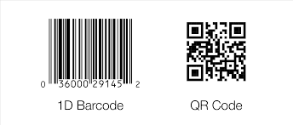

**Create charts and graph?**

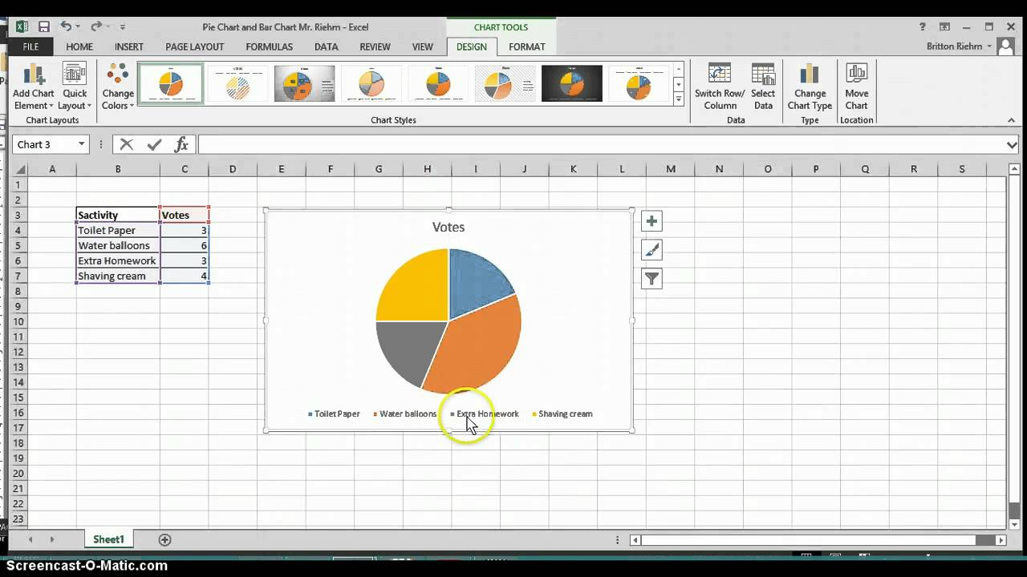

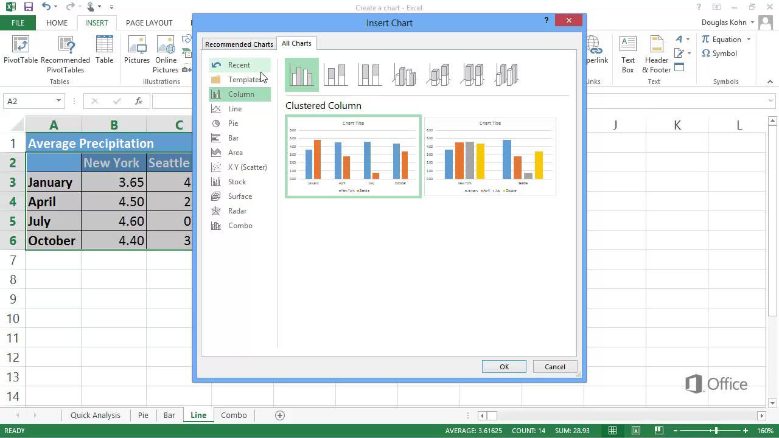

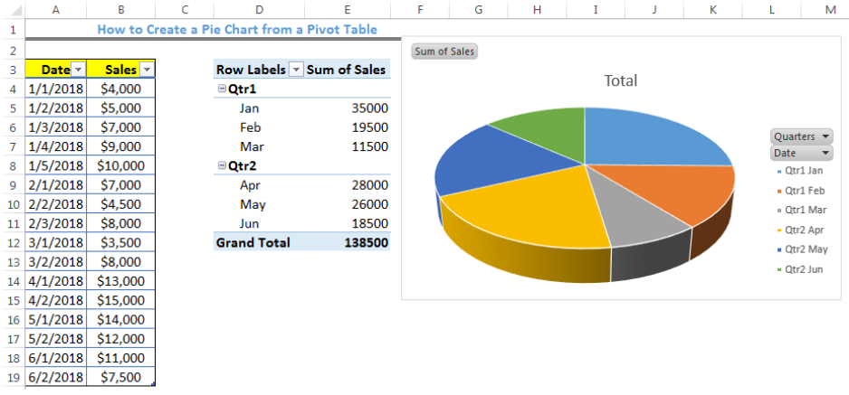

Pencil tool

* The Pencil tool is used to draw free hand lines with a hard edge. The pencil and paintbrush are similar tools. The main difference between the two tools is that although both use the same type of brush, the pencil tool will not produce fuzzy edges, even with a very fuzzy brush. It does not even do anti-aliasing.

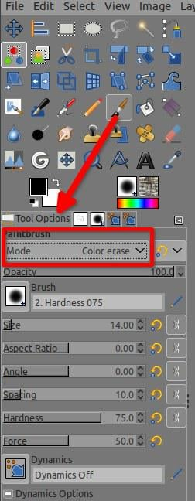

**Pencil tool practice**

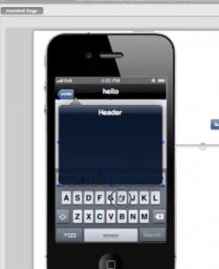

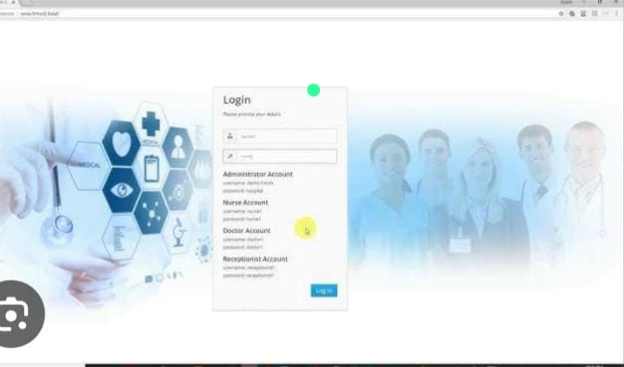



**Adobe illustrator**

Adobe Illustrator is a vector graphics software program that allows users to create illustrations, logos, icons, and other designs:



**Adobe illustrator practice**

